Student’s name
Instructor’s name
Course number
Section number
Institution affiliation
Date

In a firm or any other organization/institution, fixed and variable expenses play a significant role. All of the company's expenses are split down into fixed and variable expenses. Fixed costs are unaffected by output, but variable costs fluctuate. It's also called "mixed cost" on occasion. The following is a list of the projects presented to the CFO: methods to cost behavior analysis, patiently waiting for adequate compensation, and creating a separate expenditure sheet for any minor outlays.
The cost-cutting strategies used by hospitals are entirely dependent on how they spend their money and how they disguise the unaffordable costs. Equipment, building, labor, and fixed overhead account for the bulk of the costs covered by the hospital. All of these variables have astronomically high maintenance costs. (Kim 2019).
The cost behavior approach refers to the link between costs and the volume of services provided by a hospital. The fundamental cost structure is another name for this. The CFO may anticipate cost behavior at a distinct level of operations if the hospital knows its cost behavior.
Summary of the Recommendation:
For the sake of decision-making, an overview of fixed and variable costs is provided.
Procedure for determining hospital expenditures that aren't readily apparent Decision-making authority in the event of a closure or a downturn outline the factors that must be considered to reduce hospital waste cost. Concentrate on the aspects of the service that you're providing. Avoid variables that harm hospital and economic forums' performance.

Hospitals cost behavior
Fixed costs
Fixed costs are those that remain constant regardless of the degree of activity in the relevant spectrum. Even when no units are created, these expenses will be spent—expenses such as rent, straight-line depreciation, and so on. With increased output, the fixed cost per unit lowers. (Walus 2021).
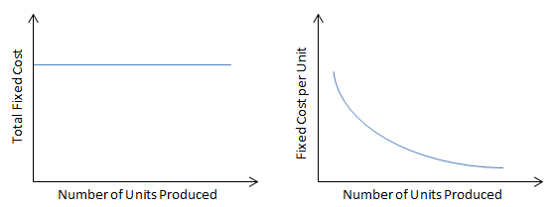
Variable costs
Costs that change in exact correlation to production levels are called variable costs. This means that the total variable cost increases as the quantity produced increases and decreases as the quantity produced decreases. The mean variable costs do not change. (Ranieri, 2020).
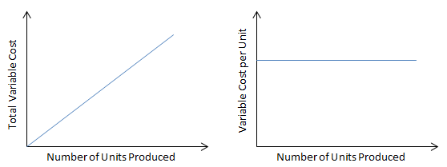

Cost drivers
A cost driver is the source of a cost, and it impacts the overall cost. For example, if you want to figure out how much power you used at a certain time, the number of units you used affects your total cost. The number of units of power used becomes a cost driver in such a circumstance.
The cost behavior of hospitals is determined by the relationship between expenditures and the number of services provided. It's also known as the underlying cost structure or the cost behavior method. The CFO may anticipate the cost factors at a particular operational level if the hospital sets its cost behavior. It nearly completely covers the hospital's cost-to-change ratio as well as the expected cost per procedure. (According to Larson, the year is 2021.)
Summary of the recommendations.
a) A description of fixed and variable costs as they relate to the decision-making process.

b) Procedures for determining hospital charges that aren't readily apparent.
b) Decision-making authority in the event of a shutdown or a power outage.
d) A summary of the factors necessary to decrease resource waste in a hospital.
a) Consider the aspects that influence hospital and economic forums' performance.
f) Manage the day-to-day operations of cost.

Reference
Grass, F., Merchea, A., Mathis, K. L., Mishra, N., Heien, H., Sangaralingham, L. R., & Larson, D. W. (2021). Cost drivers of locally advanced rectal cancer treatment—An analysis of a leading healthcare insurer. Journal of Surgical Oncology, 123(4), 1023-1029.
Lucchese, A., Marino, A., & Ranieri, L. (2020). Minimization of the Logistic Costs in Healthcare supply chain: a hybrid model. Procedia Manufacturing, 42, 76-83.
Holbe, F., & Walus, A. (2021). Pediatrics in Rural Regions Caught between Thrift and Ensuring Adequate Healthcare Provision. Gesundheitswesen (Bundesverband der Arzte des Offentlichen Gesundheitsdienstes (Germany)).
Kim, J. W., Lee, C. K., Lee, J. K., Jeong, S. J., Oh, S. J., Moon, J. R., ... & Kim, H. J. (2019). Long-term evolution of direct healthcare costs for inflammatory bowel diseases: A population-based study (2006–2015). Scandinavian journal of gastroenterology, 54(4), 419-426.

